Name: Allen Taylor
HOMEWORK #2 – Week 2

This homework is worth 10% of your course grade.

Read each problem carefully. Failure to follow the instructions for a problem will result in a zero score for that problem.

Submit the completed Homework via Assignment in LEO.

1. Construct a truth table for the Boolean equation:
M = !AB!C + !ABC + A!BC + ABC

A | B | C | M
0 | 0 | 0 | 0
0 | 0 | 1 | 0
0 | 1 | 0 | 1
0 | 1 | 1 | 1
1 | 0 | 0 | 0
1 | 0 | 1 | 1
1 | 1 | 0 | 0
1 | 1 | 1 | 1

2. Draw a simple NOT, AND, OR circuit in sum of products (SOP) form that represents the equation above.

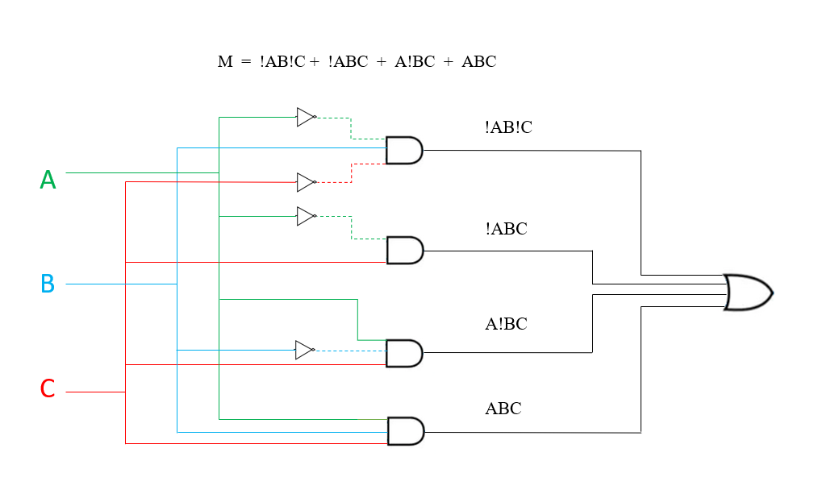

3. The truth table for a Boolean expression is shown below. Write the Boolean expression on SOP form

F(x, y, z) = (!x!y!z) + (!xyz) + (x!y!z) + (x!yz) + (xyz)

x | y | z | F
0 | 0 | 0 | 1 | !x!y!z
0 | 0 | 1 | 0
0 | 1 | 0 | 0
0 | 1 | 1 | 1 | !xyz
1 | 0 | 0 | 1 | x!y!z
1 | 0 | 1 | 1 | x!yz
1 | 1 | 0 | 0
1 | 1 | 1 | 1 | xyz

4. Find the truth table that describes the following circuit:

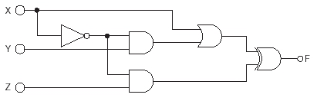

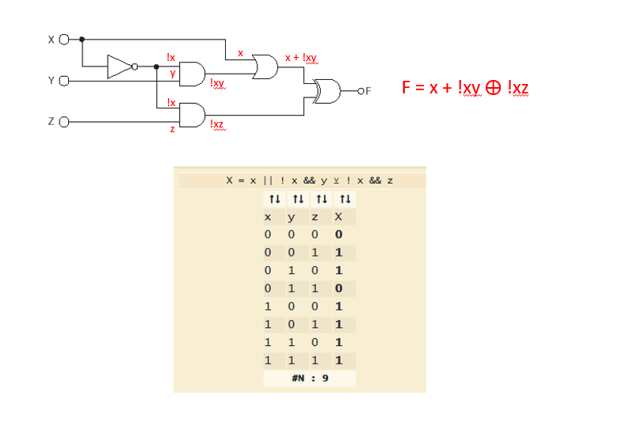

x | y | z | F
0 | 0 | 0 | 0
0 | 0 | 1 | 1
0 | 1 | 0 | 1
0 | 1 | 1 | 0
1 | 0 | 0 | 1
1 | 0 | 1 | 1
1 | 1 | 0 | 1
1 | 1 | 1 | 1

5. Describe the function of a decoder circuit; identify the types and quantity of gates needed to implement a 3-to-8 decoder; either create (or give the location in the text) of a logic diagram of a decoder circuit.

- “A decoder uses the inputs and their respective values to select one specific output line.” Decoders are the reverse of an encoder.
- 8 AND gates and 3 NOT gates
- 3.6 COMBINATIONAL CIRCUITS FIGURE 3.23

